

**JULY 2013**

**Globsyn Finishing School**

**THE BANK OF GOTHAM CITY**

**adarsh mohata**

PHP & MY-SQL

NET-BANKING PROJECT

**Online Banking System Using PHP**

Group Members:

Adarsh Mohata

National Institute Of Technology, Surathkal 17102

Ashish Kedia

National Institute Of Technology, Surathkal 16936

Moumita Ghosh

Jalpaiguri Government Engineering College 15890

Tanaya Mondal

Jalpaiguri Government Engineering College 15885

**Index**

|  |  |  |
| --- | --- | --- |
| Serial No. | Topic | Page No. |
| 1. | Acknowledgement | 3 |
| 2. | Requirement specification | 4-5 |
| 3. | Database design | 6-8 |
| 4. | Screen shots | 9-12 |
| 5. | Sample codes | 13-24 |
| 6. | Future scope of improvement | 25 |
| 7. | Conclusion | 26 |

**Acknowledgement**

This is to mention in a small way the help we got from various sources including the websites Google.com, w3schools.com, numerous online banking sites of HDFC, State Bank of India, Axis Bank, Canara Bank, Bank of India, Punjab National Bank, ICICI Bank, etc. We were also helped by a book “Advanced CSS”.Last but not the least we would always be grateful to our instructor Abhishek Kundu Sir for his immense help throughout our course and project work. And ofcourse a big thanks to the gfs community of GLOBSYN SKILLS who motivated us to produce a successful project.

**Requirement Specification**

* Domain Description:

*A system allowing individuals to perform banking activities at home, via the internet. Some online banks are traditional banks which also offer online banking, while* others are online *only and have no physical presence. Online banking through traditional banks enable customers to perform routine transactions such as transfer funds, balance inquiries, get mini statements, and stop-payment requests, and some even offer online loan applications.*

*Account information can be accessed anytime, day or night, and can be done from anywhere. A few online banks update information in real-time, while others do it daily. Once information has been entered, it doesn't need to be re-entered for similar subsequent checks, and future payments can be scheduled to occur automatically. Despite the advantages, there are a few drawbacks. It does take some time to set up and get used to an online account. Also, some banks only offer online banking in a limited area. In addition, when an account holder pays online, he/she may have to put in a check request as much as two weeks before the payment is due, but the bank may withdraw the money from the account the day that request is received, meaning the person has lost up to two weeks of interest on that payment. Online-only banks have a few additional drawbacks: an account holder has to mail in deposits (other than direct deposits), and some services that traditional banks offer are difficult or impossible for online-only banks to offer, such as cashier's checks.*

* Functional Requirements:

*As per the facilities provided by several online banking softwares, our project aims at covering the following functionalities to serve the customers having account in our bank in a better way-*

1. *Opening new accounts.*
2. *Viewing the account details.*
3. *Getting ones accounts summary.*
4. *Obtaining mini statements.*
5. *Balance enquiry.*
6. *Transfer funds to another account in the same bank.*
7. *Request for cheque book.*
8. *Request for loan and sanctioning of the same .*

* Hardware Specification:

*PC with 2 GB hard-disk and 256 MB RAM*

* Software Specification:

|  |  |  |
| --- | --- | --- |
| Number | Description | Version |
| 1 | XAMPP | 3.1.0 |
| 2 | Apache | 2.4.3(Win32)OpenSSL/1.0.1c  PHP/5.4.7 |
| 3 | MySQL | 5.5.27-MySQL Community  Server |
| 4 | Net Beans IDE | 7.1 |
| 5 | Operating System | Windows XP or Above |

**Database Design**

* E-R Diagram:

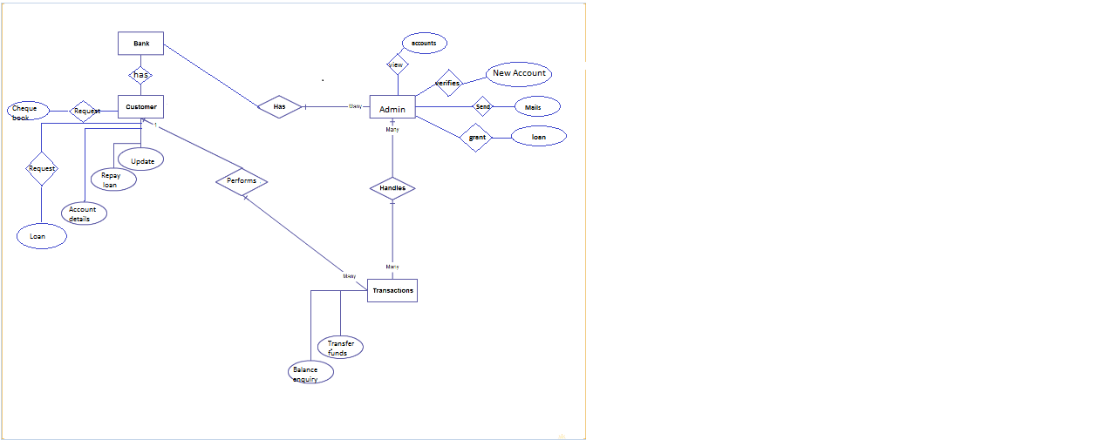

E-R Diagram of online banking system

* *Table Description:*

*The database used in this project is ‘netbanking’using MySQL server.The database consists of the following tables:*

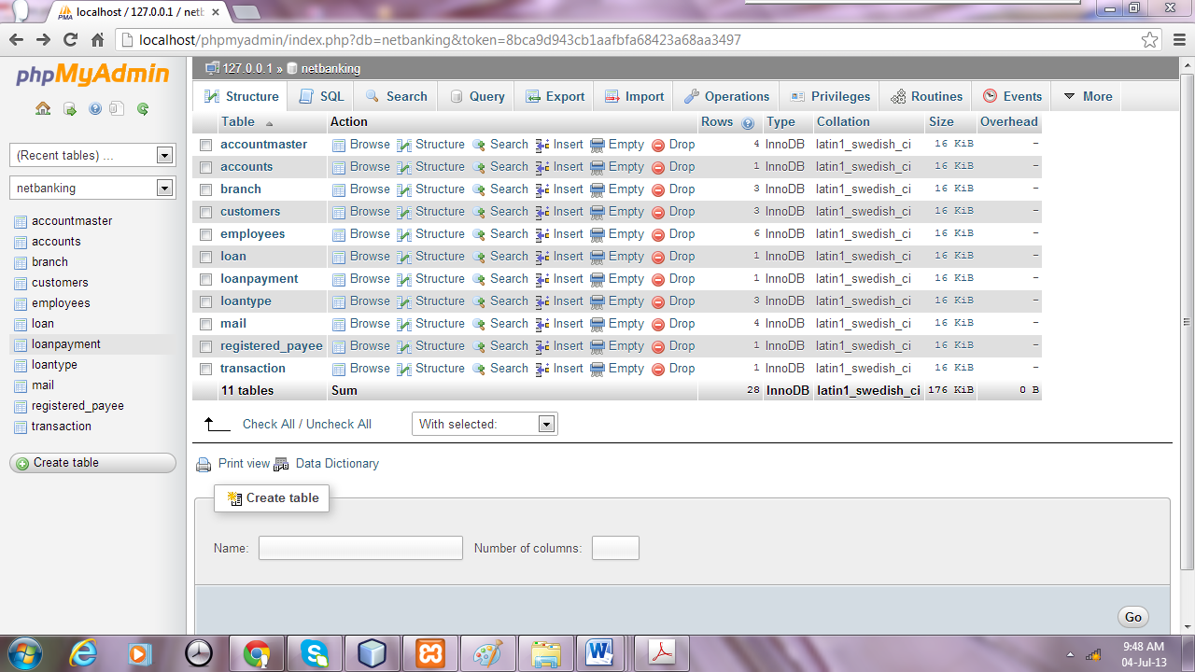

*The functionalities and attributes of each table are described in the next page:*

|  |  |  |
| --- | --- | --- |
| TABLE NAME | ATTRIBUTES | FUNCTIONALITY |
| Accountmaster | Accounttype, prefix,  minbalance, interest | Details of all types of account. |
| Accounts | Accno,customerid,accstatus,  Primaryacc,accopendate,  accounttype,accountbalance  Unclearbalance,accuredinterest | Details of the accounts,the customers have. |
| Branch | Ifscode,branchname,city,  branchaddress,state,country | Details of the bank’s branches. |
| Customers | Customerid,ifscode,firstname,  lastname,Loginid,accpassword,  transpasword,accstatus,city,state  country,accopendate,lastlogin | Details of the customer. |
| Employees | Empid,employee_name,loginid,  passwordEmailid,contactno,  createdat,last_login | Details of the bank’s employees |
| Loan | Loanid,loantype,loanamt,  Interest,startdate | Loan specification |
| Loanpayment | Paymentid,date,paidamt,  loanid | Details of the loans paid |
| Loantype | Loantype,prefix,maximumamt,  minimumamt,Interest,status | Details of all types of loan |
| mail | Mailid,subject,message,  mdatetime,Senderid,receiverid | Details of received and sent mails |
| Registered_payee | Customerid,payeename,  Accountnumber, Accounttype  bankname,ifsccode | Details of the payee |
| Transaction | Transtractionid,transactiondate,ment  Paymentdate,Payeeid,receiveid,  debitac,amount,paymentstat | Details of transaction done. |

**Screen Shots**

**There are several functions of the site. A few snapshots of some important pages of this site are shown below:**

This is the homepage of our online banking project-‘The Bank Of Gotham City’.

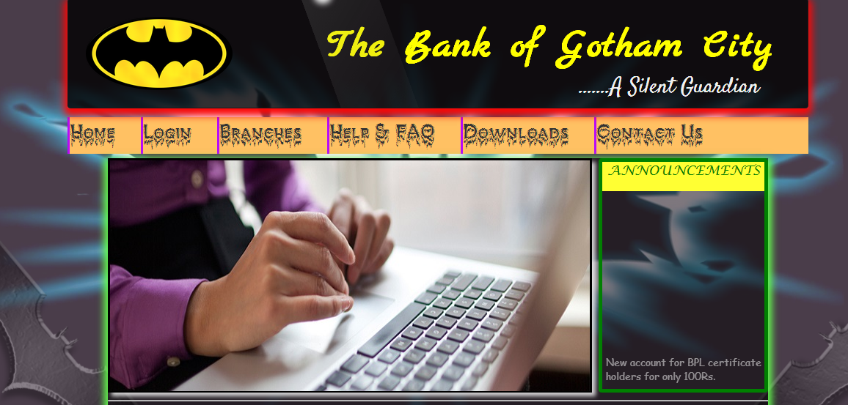

This is the login page of the bank.

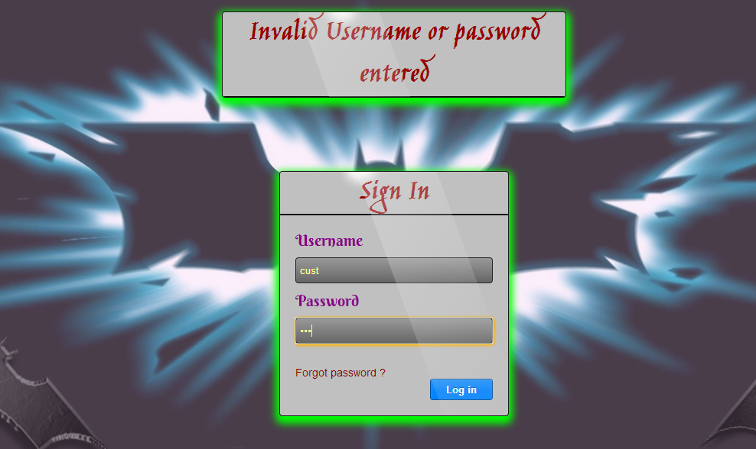

This page shows information about different branches of the bank.

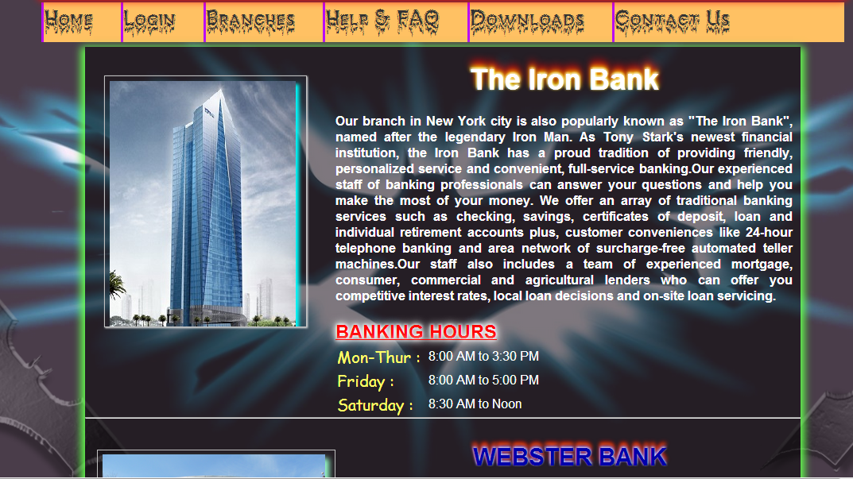

This is the administrator’s dashboard.

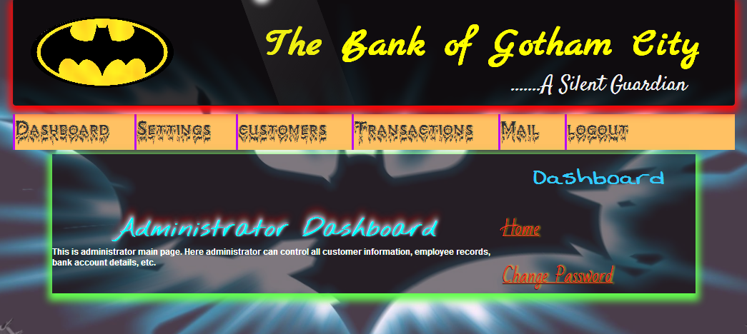

This is the customer’s section.

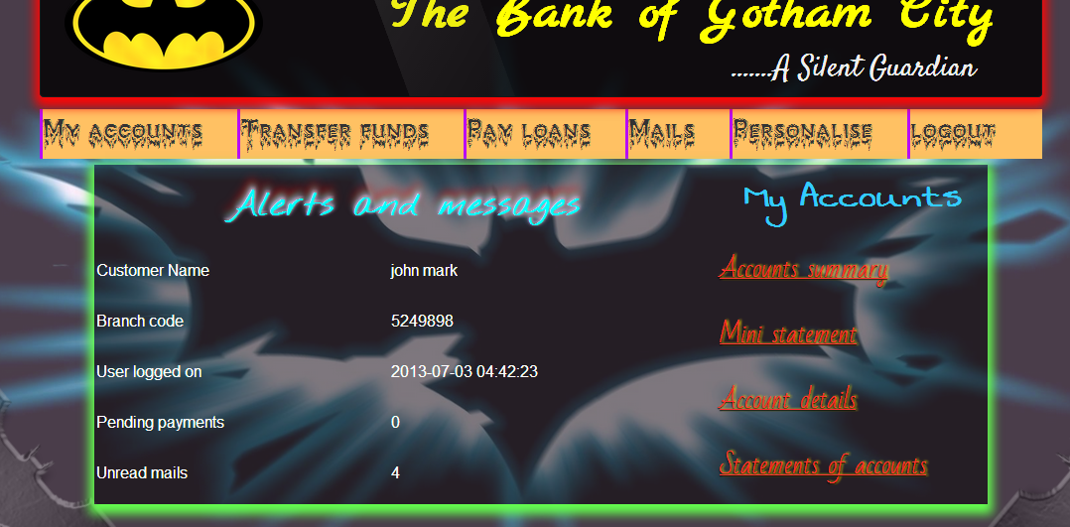

And this page shows the details of the account of a particular customer.

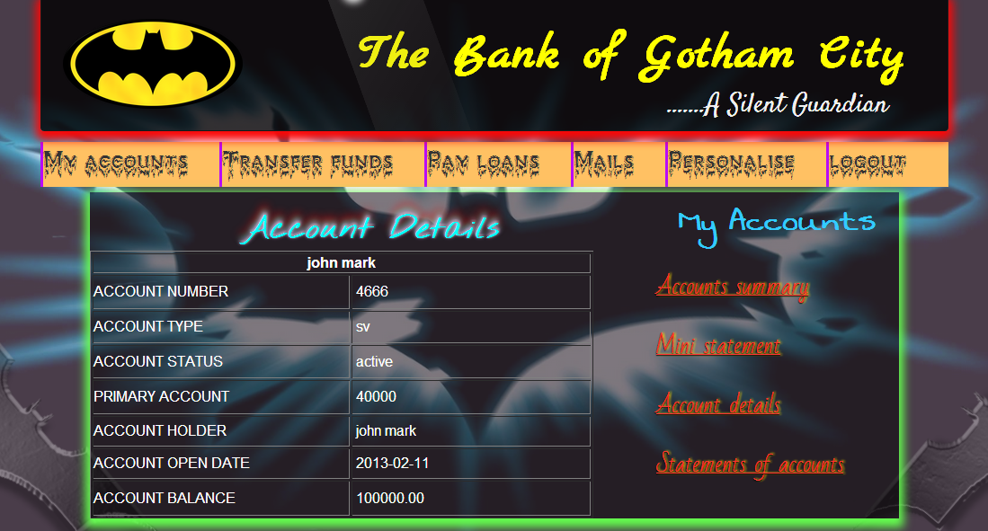

And is this the contact-us page.

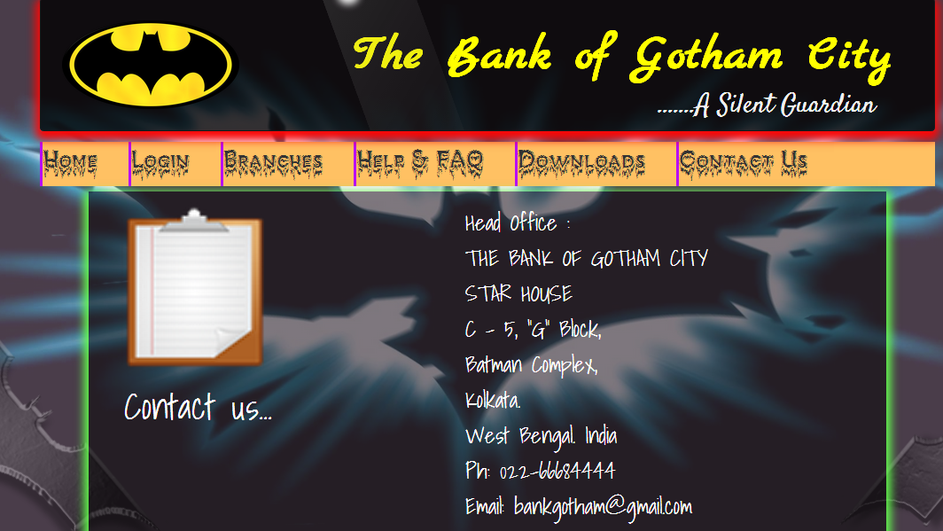

**Sample** **Codes**

* + *Index.php:*

<?php

session_start();

error_reporting(0);

include("dbconnection.php");

if(isset($_SESSION['customerid']))

{

header("Location: accountalerts.php"); exit(0);

}

if(isset($_SESSION['adminid']))

{

header("Location: admindashboard.php");

}

?>

<html>

<head>

<meta http-equiv="Content-Type" content="text/html; charset=utf-8" />

<title>The Bank of Gotham City</title>

<link href="css/LoginPageStyle.css" rel="stylesheet" type="text/css" />

</head>

<body>

<img id="contain" src="images/batman2.jpg">

<div><img src="images/batman1.png" id="batimg1"><img src="images/batman1.png" id="batimg2"></div>

<div id="bodycontent">

<div id="templatemo_wrapper">

<div class="mainbox">

<img src="images/logo.png" width="200" height="100" style="float:left; margin:2em 2em;">

<div id="site_title">

<h1 style="margin-top: 30px;"><a href="index.php" style="color:yellow; text-decoration: none; margin-left: 1em;"><span>The Bank of Gotham City</span></a></h1>

<p style="float:right; margin-right: 2.2em; color: buttonface; font-family: Satisfy,cursive; font-size: 2.5em;">.......A Silent Guardian</p>

</div> <!-- end of site_title -->

</div> <!-- end of header -->

<div id="toptabmenu">

<ul id="nav">

<li><a href="index.php">Home</a></li>

<li><a href="login.php">Login</a></li>

<li><a href="branches.php">Branches</a></li>

<li><a href="help.php">Help & FAQ</a></li>

<li><a href="">Downloads</a>

<ul>

<li><a href="downloads/New_Account.pdf">New Account form</a></li>

<li><a href="">Loan Forms</a>

<ul>

<li><a href="downloads/home_loan_application_form.pdf">Home Loan</a></li>

<li><a href="downloads/Car_Loan_Application_Form.pdf">Car Loan</a></li>

<li><a href="downloads/Education_Loan_Application_Form.pdf">Educational Loan</a></li>

</ul>

</li>

<li><a href="downloads/ChequeBook_Request.pdf">Cheque book request</a></li>

</ul>

</li>

<li><a href="contactus.php">Contact Us</a></li>

</ul>

</div>

</div>

<div id="templatemo_main">

<div id="content-slider" class="b">

<div id="slider" style="float:left">

<div id="mask">

<ul>

<li id="first" class="firstanimation">

<img src="images/img_1.jpg"/>

</li>

<li id="second" class="secondanimation">

<img src="images/img_2.jpg"/>

</li>

<li id="third" class="thirdanimation">

<img src="images/img_3.jpg"/>

</li>

<li id="fourth" class="fourthanimation">

<img src="images/img_4.jpg"/>

</li>

<li id="fifth" class="fifthanimation">

<img src="images/img_5.png"/>

</li>

</ul>

</div>

</div>

<div class="ex"><div class="heading">ANNOUNCEMENTS</div><br/><div class="low">

<ul style="list-style-type:none;">

<li class="one">Board meeting on 11/07/2013<br/><br/></li>

<li class="two">Withdrawal limit of ATM rises<br/> from Rs 25000 to Rs 40000<br/><br/></li>

<li class="three">Annual return forms available at<br/> your nearest branches now.<br/><br/></li>

<li class="four">Fill your E-tax forms and submit<br/> within 30th July<br/><br/></li>

<li class="five">New account for BPL certificate <br/> holders for only 100Rs.<br/></li>

</ul>

</div></div>

</div>

<hr/><br/>

<div class="home">

<div class="begin"> Now monitor, transact and control your bank account online through our net banking service.

You can do multiple things from the comforts of your home or office with our Internet Banking - a one stop solution

for all your banking needs.You can now get all your accounts details, submit requests and undertake a wide range of transactions online. Our E-Banking service

makes banking a lot more easy and effective.</div><br/><br/>

<span id="feat" ><b><u>Features</u></b></span><br/><br/>

<ul style="padding-left:2em;list-style-image:url('images/next_blue.png');align:middle;"><li><span class="subhead">Account Details</span><br/><br/>View your bank account details, account balance, download statements and more. Also view your Demat,

Loan & Credit Card Account Details too all in one place.</li><br/>

<li><span class="subhead">Fund Transfer</span><br/><br/>Transfer fund to your own accounts,Other Gotham Bank accounts seamlessly.</li><br/>

<li><span class="subhead">Request Services</span><br/><br/>Give a request for Cheque book,Demand Draft,Stop Cheque Payment,Debit Card Loyalty Point Redemption etc.</li><br/>

<li><span class="subhead">Investment Services</span><br/><br/>View your complete Portfolio with the bank, Create Fixed Deposit, Apply for IPO </li><br/>

<li><span class="subhead">Value Added Services</span><br/><br/>Pay Utility bills for more than 160 billers, Recharge Mobile, Create Virtual Cards, Pay any Visa Credit Card bills,

Register for estatement and sms banking</li></ul><br/>

<div class="begin">Register now for Gotham Bank's internet banking service to get started and avail for you multiple utility services, all in a matter of a click. Getting started with our internet banking is real easy.

All you need to do is follow a few simple steps and you are good to go. <a href="register.php">Click here</a> for our registration process

<p>We at the B.O.G.C follow best-in-class online security practices in order to safeguard your information while you are banking online. We are constantly at task for preventing fraud and thereby making all your net banking transactions completely safe.

</div>

</div>

</div> <!-- end of main -->

</div>

<?php include'footer.php' ?>

</body>

</html>

* *Login.php:*

<?php

session_start();

error_reporting(0);

include("dbconnection.php");

if(($_REQUEST['error'])=='nologin')

$logininfo="Please Sign In to Continue";

else if(($_REQUEST['error'])=='forgetpass')

$logininfo="Please contact the nearest branch";

if(isset($_SESSION['customerid']))

{

header("Location: accountalerts.php"); exit(0);

}

if(isset($_SESSION['adminid']))

{

header("Location: admindashboard.php");

}

if (isset($_SESSION['employeeid']))

{

header("Location:employeeacount.php");

}

if ((isset($_REQUEST['login'])))

{

$password = mysql_real_escape_string($_REQUEST['password']);

$logid= mysql_real_escape_string($_REQUEST['login']);

$query="SELECT * FROM customers WHERE loginid='$logid' AND accpassword='$password'";

$res= mysql_query($query);

if(mysql_num_rows($res) == 1)

{

while($recarr = mysql_fetch_array($res))

{

$_SESSION['customerid'] = $recarr['customerid'];

$_SESSION['ifsccode'] = $recarr['ifsccode'];

$_SESSION['customername'] = $recarr['firstname']. " ". $recarr['lastname'];

$_SESSION['loginid'] = $recarr['loginid'];

$_SESSION['accstatus'] = $recarr['accstatus'];

$_SESSION['accopendate'] = $recarr['accopendate'];

$_SESSION['lastlogin'] = $recarr['lastlogin'];

}

$_SESSION["loginid"] =$_POST["login"];

header("Location: accountalerts.php");

}

else{

$res = mysql_query("SELECT * FROM employees WHERE loginid='$logid' AND password='$password'");

if(mysql_num_rows($res) == 1)

{

$_SESSION["adminid"] =$_POST["login"];

header("Location: admindashboard.php");

}

else

{

$logininfo = "Invalid Username or password entered";

}

}

}

?>

<html>

<head>

<meta http-equiv="Content-Type" content="text/html; charset=utf-8" />

<title>The Bank of Gotham City</title>

<link href="css/LoginPageStyle.css" rel="stylesheet" type="text/css" />

</head>

<body>

<img id="contain" src="images/batman2.jpg">

<div><img src="images/batman1.png" id="batimg1"><img src="images/batman1.png" id="batimg2"></div>

<div id="bodycontent">

<div id="templatemo_wrapper">

<div class="mainbox">

<img src="images/logo.png" width="200" height="100" style="float:left; margin:2em 2em;">

<div id="site_title">

<h1 style="margin-top: 30px;"><a href="index.php" style="color:yellow; text-decoration: none; margin-left: 1em;"><span>The Bank of Gotham City</span></a></h1>

<p style="float:right; margin-right: 2.2em; color: buttonface; font-family: Satisfy,cursive; font-size: 2.5em;">.......A Silent Guardian</p>

</div> <!-- end of site_title -->

</div> <!-- end of header -->

<div id="toptabmenu">

<ul id="nav">

<li><a href="index.php">Home</a></li>

<li><a href="login.php">Login</a></li>

<li><a href="branches.php">Branches</a></li>

<li><a href="help.php">Help & FAQ</a></li>

<li><a href="">Downloads</a>

<ul>

<li><a href="downloads/New_Account.pdf">New Account form</a></li>

<li><a href="">Loan Forms</a>

<ul>

<li><a href="downloads/home_loan_application_form.pdf">Home Loan</a></li>

<li><a href="downloads/Car_Loan_Application_Form.pdf">Car Loan</a></li>

<li><a href="downloads/Education_Loan_Application_Form.pdf">Educational Loan</a></li>

</ul>

</li>

<li><a href="downloads/ChequeBook_Request.pdf">Cheque book request</a></li>

</ul>

</li>

<li><a href="contactus.php">Contact Us</a></li>

</ul>

</div>

</div>

<?php if(isset($logininfo))

{ echo"<div class='logmainbox' style='width:450px;'><h1>$logininfo</h1></div>"; } ?>

<div class="logmainbox">

<form action="login.php" method="POST">

<h1>Sign In</h1>

<div class="loginset">

<p>

<label class="Ltext">Username</label>

<input type="text" name="login" class="loginput">

</p>

<p>

<label class="Ltext" for="password">Password</label>

<input type="password" name="password" class="loginput">

</p>

</div>

<p class="p-container">

<a href="login.php?error=forgetpass">Forgot password ?</a><br/>

<input type="submit" name="go" id="go" value="Log in" class="loginput">

</p>

</form>

</div>

</div>

<?php include'footer.php' ?>

</body>

</html>

* *footer.php*

<div class="footer" style="margin-bottom: 0px;">

<img src="images/batman3.png" style="float:left; z-index: 4; position: absolute;" height="200">

<div style="height:100px; float:left; width:90em; margin-top: 100px; margin-left: 120px;text-align: center; z-index: 3; position: absolute;" class="mainbox">

<h1 style="font-size:2em; font-family: 'Kaushan Script'; color:#990099;">Developed @ Globsyn Summer School</h1>

<h3 style="font-size:1.5em; font-family: 'Kaushan Script'; color:#ff33ff;">PHP & MYSQL Project</h3>

<p style="font-size: 22px; font-family:'Berkshire Swash',cursive; color:orange;"><marquee direction="left" onMouseOver="this.stop()" onMouseOut="this.start()">Made By: Adarsh Mohata, Ashish Kedia, Tanaya Mondal, Moumita Ghosh </marquee> </p>

</div>

<img src="images/jokerx.png" style=" z-index: 4; float: right; position: absolute; margin-left:99em;" height="200">

</div>

* *branches.php*

<?php

session_start();

error_reporting(0);

include("dbconnection.php");

if(isset($_SESSION['customerid']))

{

header("Location: accountalerts.php"); exit(0);

}

if(isset($_SESSION['adminid']))

{

header("Location: admindashboard.php");

}

if (isset($_SESSION['employeeid']))

{

header("Location:employeeacount.php");

}

?>

<html>

<head>

<meta http-equiv="Content-Type" content="text/html; charset=utf-8" />

<title>The Bank of Gotham City</title>

<link href="css/LoginPageStyle.css" rel="stylesheet" type="text/css" />

<link href="css/style.css" rel="stylesheet" type="text/css" />

</head>

<body>

<img id="contain" src="images/batman2.jpg">

<div><img src="images/batman1.png" id="batimg1"><img src="images/batman1.png" id="batimg2"></div>

<div id="bodycontent">

<div id="templatemo_wrapper">

<div class="mainbox">

<img src="images/logo.png" width="200" height="100" style="float:left; margin:2em 2em;">

<div id="site_title">

<h1 style="margin-top: 30px;"><a href="index.php" style="color:yellow; text-decoration: none; margin-left: 1em;"><span>The Bank of Gotham City</span></a></h1>

<p style="float:right; margin-right: 2.2em; color: buttonface; font-family: Satisfy,cursive; font-size: 2.5em;">.......A Silent Guardian</p>

</div> <!-- end of site_title -->

</div> <!-- end of header -->

<div id="toptabmenu">

<ul id="nav">

<li><a href="index.php">Home</a></li>

<li><a href="login.php">Login</a></li>

<li><a href="branches.php">Branches</a></li>

<li><a href="help.php">Help & FAQ</a></li>

<li><a href="">Downloads</a>

<ul>

<li><a href="downloads/New_Account.pdf">New Account form</a></li>

<li><a href="">Loan Forms</a>

<ul>

<li><a href="downloads/home_loan_application_form.pdf">Home Loan</a></li>

<li><a href="downloads/Car_Loan_Application_Form.pdf">Car Loan</a></li>

<li><a href="downloads/Education_Loan_Application_Form.pdf">Educational Loan</a></li>

</ul>

</li>

<li><a href="downloads/ChequeBook_Request.pdf">Cheque book request</a></li>

</ul>

</li>

<li><a href="contactus.php">Contact Us</a></li>

</ul>

</div>

</div>

<div id="templatemo_main">

<div class="image view"><img src="images/iron bank.jpg" alt="The Iron Bank" title="The Iron Bank" /><div class="mask">

<h2>CHAIRMAN</h2>

<p>Mr. Tony Stark</p><br/><br/>

<h2>EXECUTIVE DIRECTOR</h2>

<p>Ms. Pepper Potts</p>

</div></div>

<div class="brcont"><h2>The Iron Bank</h2><br/>Our branch in New York city is also popularly known as "The Iron Bank", named after the legendary Iron Man.

As Tony Stark's newest financial institution, the Iron Bank has a proud tradition of providing friendly,

personalized service and convenient, full-service banking.Our experienced staff of banking professionals can answer your

questions and help you make the most of your money. We offer an array of traditional banking services such as checking,

savings, certificates of deposit, loan and individual retirement accounts plus, customer conveniences like 24-hour telephone

banking and area network of surcharge-free automated teller machines.Our staff also includes a team of experienced mortgage,

consumer, commercial and agricultural lenders who can offer you competitive interest rates, local loan decisions and on-site

loan servicing.<br/><br/>

<span style="font-size:24px;color:red; text-shadow: 0 0 5px #fff,

0 0 10px #fff,

0 0 15px #fff,

0 0 20px #fff;"><u>BANKING HOURS</u></span><br/>

<table><tr><td id="td">Mon-Thur :</td><td> &nbsp;&nbsp;8:00 AM to 3:30 PM</td></tr>

<tr><td id="td">Friday :</td><td> &nbsp;&nbsp;8:00 AM to 5:00 PM</td></tr>

<tr><td id="td">Saturday :</td><td> &nbsp;&nbsp;8:30 AM to Noon</td></tr></table>

</div><hr/><br/>

<div style="border:thin solid silver; width:300px;height:230px; text-align:center;margin-left:15px;float:left;margin-top:2em;">

<div id="cf4" class="hover">

<div class="top" style="width:280;height:220;">

<h2>CEO</h2>

<p>Mr. Peter Parker</p><br/><br/>

<h2>MANAGING DIRECTOR</h2>

<p>Ms. Mary Jane Watson</p></div>

<img class="bottom" src="images/webster_bank.jpg" alt="Webster Bank" name="VidSet" width="280" height="220">

</div>

</div>

<div class="web" ><h2>WEBSTER BANK</h2>

As Spiderman's premium foundation,our branch in Boston known as the Webster Bank has been committed to helping individuals, families and businesses achieve

their financial goals. In that mission, Webster’s 3,000 bankers are guided by our core values, namely, to take personal

responsibility for meeting our customers’ needs; to respect the dignity of every individual; to earn trust through ethical behavior;

to give of ourselves to our communities; and to work together to achieve outstanding results.<br/>

Webster Bank provides consumer, business, government and institutional banking, as well as mortgage, financial planning, trust

and investment services through Webster Private Bank. Webster has 294 ATMs and delivers superior customer service in person, on the phone,

online, and through mobile devices.<br/><br/>

<span style="font-size:24px;color:red; text-shadow: 0 0 5px #fff,

0 0 10px #fff,

0 0 15px #fff,

0 0 20px #fff;"><u>BANKING HOURS</u></span><br/>

<table><tr><td id="td">Mon-Fri :</td><td> &nbsp;&nbsp;9:00 AM to 4:30 PM</td></tr>

<tr><td id="td">Saturday :</td><td> &nbsp;&nbsp;9:30 AM to 1:30 PM</td></tr></table>

</div>

</div>

</div>

<?php include'footer.php' ?>

</body>

</html>

* transferfunds.php:

<?php

session_start();

error_reporting(0);

include("dbconnection.php");

if(!(isset($_SESSION['customerid'])))

header('Location:login.php?error=nologin');

$result = mysql_query("select * from registered_payee WHERE customer_id='$_SESSION[customer_id]'");

?>

<html>

<head>

<meta http-equiv="Content-Type" content="text/html; charset=utf-8" />

<title>The Bank of Gotham City</title>

<link href="css/LoginPageStyle.css" rel="stylesheet" type="text/css" />

</head>

<body>

<img id="contain" src="images/batman2.jpg">

<div><img src="images/batman1.png" id="batimg1"><img src="images/batman1.png" id="batimg2"></div>

<div id="bodycontent">

<div id="templatemo_wrapper">

<div class="mainbox">

<img src="images/logo.png" width="200" height="100" style="float:left; margin:2em 2em;">

<div id="site_title">

<h1 style="margin-top: 30px;"><a href="index.php" style="color:yellow; text-decoration: none; margin-left: 1em;"><span>The Bank of Gotham City</span></a></h1>

<p style="float:right; margin-right: 2.2em; color: buttonface; font-family: Satisfy,cursive; font-size: 2.5em;">.......A Silent Guardian</p>

</div> <!-- end of site_title -->

</div> <!-- end of header -->

<div id="toptabmenu">

<ul>

<li><a href="accountalerts.php">My accounts</a></li>

<li><a href="transferfunds.php">Transfer funds</a></li>

<li><a href="payloans.php">Pay loans</a></li>

<li><a href="mailinbox.php">Mails</a></li>

<li><a href="changetranspass.php">Personalise</a></li>

<li><a href="logout.php">logout</a></li>

</ul>

</div>

</div>

<div id="templatemo_main">

<div id="sidecon">

<h2>Fund Transfer</h2>

<form id="form1" name="form1" method="post" action="">

<p style="font-size:18px;">Fund Transfer menu provide you to make fund transfers between your different accounts as well as making a transfer to a third party. You can even make an enquiry about your transfers and view the pending transfers through this menu.</p>

</form>

</div>

<div id="sidebar">

<h2>Transfer Funds</h2>

<ul>

<li><a href="addexternalpayee.php">Add External Payee</a></li>

<li><a href="viewexternalpayee.php">View registered Payee</a></li>

<li><a href="Makepayment.php">Make a Payement</a></li>

<li><a href="Transactionmade.php?pst=Complete">Payements Made</a></li>

</ul>

</div>

</div>

<?php include'footer.php' ?>

</div>

</body>

</html>

**Future Scope of Improvement**

Our project aims at the delivery of proper services to the users, but still we lack some utilities. For this inconvenience we are trying to bring in as much facilities as possible. In our development process we will firstly attempt for the online deposit and withdrawal of money from the bank. We will try to make the system more secure and free it from any flaws currently present. To reduce the work of the administrator will be a major concern, where we shall attempt to shift the verifying activities of each account details from manually to the system.

**Conclusion**

**This was a small attempt from our side to create a prototype of a system, vital nowadays in everyone’s life. In spite of its drawbacks, hope it will serve the people upto a certain extent and on our side we shall try to enhance the system for the betterment of society.**

**THANK YOU!!**